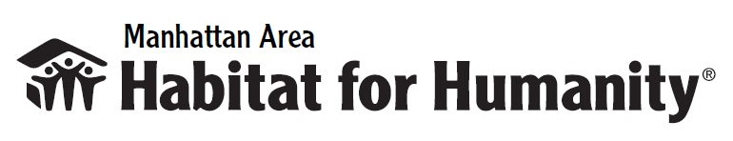

BUILDING ON FAITH FACT SHEET

- Habitat for Humanity and Thrivent are expanding their national partnership with Building on Faith during the month of September in 2019.
- Building on Faith is for you, your churches and local faith communities to participate in a community improvement project that addresses housing needs, raises awareness of the need for affordable housing, and provides an engaging volunteer experience.
- Volunteers will participate in different types of projects across the country, including: homebuilding, rehab or repair projects, park and playground cleanup, blessings of homes, landscaping, volunteering at a Habitat ReStore, and more.
- Locally we will “Beautify Bertrand” street in Manhattan on September 25th, 5-8pm. Dinner provided. Local churches will come together to do exterior work (light painting, tree trimming, weeding, etc.) on the street adjacent to our recently completed Habitat Home. Details found at mahfh.org/buildingonfaith
- Nationwide, thousands of volunteers are expected to participate in Building on Faith 2019.
- Since 2005, Thrivent and its members have contributed over 5.85 million volunteer hours and over $253 million to improve communities through affordable housing solutions.

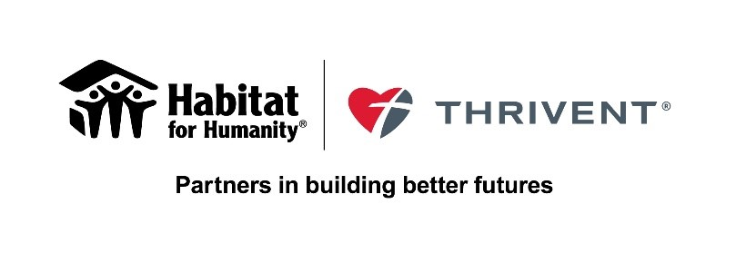
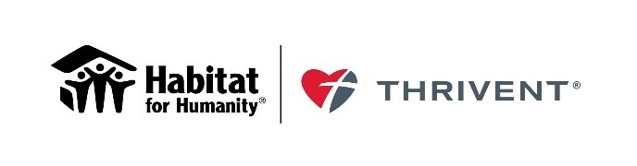For more information, please contact: Melody Sexton, MAHFH Office Manager, office@mahfh.org

